Part 1: Data Preprocessing

Q1

Train.head() and test.head()

|  | **age** | **sex** | **bmi** | **children** | **smoker** | **charge** | **label** | **northeast** | **northwest** | **southeast** | **southwest** |
| --- | --- | --- | --- | --- | --- | --- | --- | --- | --- | --- | --- |
| **0** | 27 | 1 | 28.500 | 0 | 1 | 18310.74200 | 1 | 0 | 1 | 0 | 0 |
| **1** | 18 | 0 | 37.290 | 1 | 0 | 2219.44510 | 0 | 0 | 0 | 1 | 0 |
| **2** | 43 | 0 | 20.045 | 2 | 1 | 19798.05455 | 1 | 1 | 0 | 0 | 0 |
| **3** | 35 | 0 | 38.095 | 2 | 0 | 24915.04626 | 1 | 1 | 0 | 0 | 0 |
| **4** | 59 | 1 | 25.460 | 1 | 0 | 12913.99240 | 0 | 1 | 0 | 0 | 0 |
|  | **age** | **sex** | **bmi** | **children** | **smoker** | **charge** | **label** | **northeast** | **northwest** | **southeast** | **southwest** |
| **0** | 59 | 0 | 26.505 | 0 | 0 | 12815.44495 | 0 | 1 | 0 | 0 | 0 |
| **1** | 35 | 0 | 31.000 | 1 | 0 | 5240.76500 | 0 | 0 | 0 | 0 | 1 |
| **2** | 57 | 0 | 23.180 | 0 | 0 | 11830.60720 | 0 | 0 | 1 | 0 | 0 |
| **3** | 52 | 0 | 37.525 | 2 | 0 | 33471.97189 | 1 | 0 | 1 | 0 | 0 |
| **4** | 44 | 0 | 36.955 | 1 | 0 | 8023.13545 | 0 | 0 | 1 | 0 | 0 |

heatmap

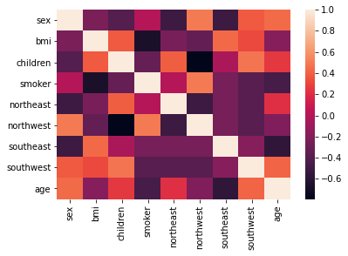

Part 2: Regression

Q2 - Q3

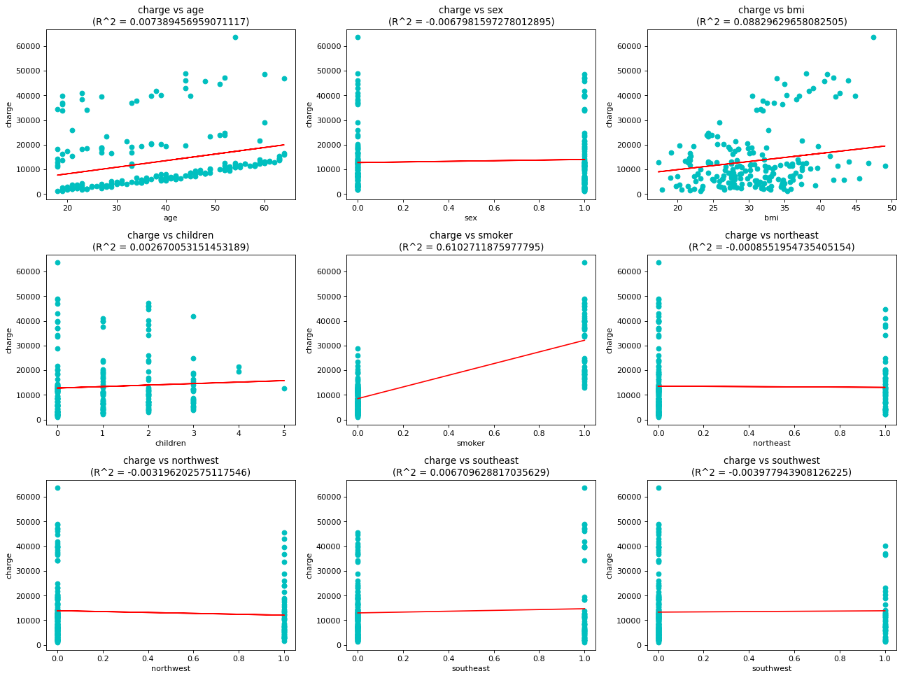

R^2 score on the validation set for the 10th regression model(the one that uses all the nine features): 0.7632440007914385

Part 3: Classification

6.1 Feature Selection

Q4

|  | **age** | **sex** | **bmi** | **children** | **smoker** | **northeast** | **northwest** | **southeast** | **southwest** |
| --- | --- | --- | --- | --- | --- | --- | --- | --- | --- |
| **f_classif** | 16.206831 | 0.184330 | 1.349763 | 1.954379 | 1363.904410 | 0.114417 | 0.233475 | 1.724736 | 1.468004 |
| **chi2** | 80.688568 | 0.092425 | 1.661031 | 2.569718 | 454.075507 | 0.086750 | 0.175358 | 1.264119 | 1.117395 |
| **mutual_info_classif** | 0.052957 | 0.000609 | 0.000000 | 0.008538 | 0.320690 | 0.000000 | 0.000000 | 0.010120 | 0.005580 |

selected features = 'age', 'bmi', 'children', 'smoker', 'northwest', 'southeast', 'southwest'

Q5

using eta0 = [0.001, 0.005, 0.01, 0.05, 0.1]

the model setting (for the repeated 3 times) followed by the training time and performance of the logistic regression model

{'alpha': 0.0001,

'average': False,

'class_weight': None,

'early_stopping': False,

'epsilon': 0.1,

'eta0': 0.001,

'fit_intercept': True,

'l1_ratio': 0.15,

'learning_rate': 'constant',

'loss': 'log',

'max_iter': 1000,

'n_iter_no_change': 5,

'n_jobs': None,

'penalty': 'l2',

'power_t': 0.5,

'random_state': None,

'shuffle': True,

'tol': 0.001,

'validation_fraction': 0.1,

'verbose': 0,

'warm_start': False}

{'alpha': 0.0001,

'average': False,

'class_weight': None,

'early_stopping': False,

'epsilon': 0.1,

'eta0': 0.001,

'fit_intercept': True,

'l1_ratio': 0.15,

'learning_rate': 'constant',

'loss': 'log',

'max_iter': 1000,

'n_iter_no_change': 5,

'n_jobs': None,

'penalty': 'l2',

'power_t': 0.5,

'random_state': None,

'shuffle': True,

'tol': 0.001,

'validation_fraction': 0.1,

'verbose': 0,

'warm_start': False}

{'alpha': 0.0001,

'average': False,

'class_weight': None,

'early_stopping': False,

'epsilon': 0.1,

'eta0': 0.001,

'fit_intercept': True,

'l1_ratio': 0.15,

'learning_rate': 'constant',

'loss': 'log',

'max_iter': 1000,

'n_iter_no_change': 5,

'n_jobs': None,

'penalty': 'l2',

'power_t': 0.5,

'random_state': None,

'shuffle': True,

'tol': 0.001,

'validation_fraction': 0.1,

'verbose': 0,

'warm_start': False}

|  | **training time** | **accuracy** | **F1 score** |
| --- | --- | --- | --- |
| **0** | 0.007999 | 9.050000e-01 | 0.825688 |
| **1** | 0.008000 | 9.050000e-01 | 0.825688 |
| **2** | 0.003995 | 9.050000e-01 | 0.825688 |
| **mean** | 0.006665 | 9.050000e-01 | 0.825688 |
| **std** | 0.001888 | 1.110223e-16 | 0.000000 |

{'alpha': 0.0001,

'average': False,

'class_weight': None,

'early_stopping': False,

'epsilon': 0.1,

'eta0': 0.005,

'fit_intercept': True,

'l1_ratio': 0.15,

'learning_rate': 'constant',

'loss': 'log',

'max_iter': 1000,

'n_iter_no_change': 5,

'n_jobs': None,

'penalty': 'l2',

'power_t': 0.5,

'random_state': None,

'shuffle': True,

'tol': 0.001,

'validation_fraction': 0.1,

'verbose': 0,

'warm_start': False}

{'alpha': 0.0001,

'average': False,

'class_weight': None,

'early_stopping': False,

'epsilon': 0.1,

'eta0': 0.005,

'fit_intercept': True,

'l1_ratio': 0.15,

'learning_rate': 'constant',

'loss': 'log',

'max_iter': 1000,

'n_iter_no_change': 5,

'n_jobs': None,

'penalty': 'l2',

'power_t': 0.5,

'random_state': None,

'shuffle': True,

'tol': 0.001,

'validation_fraction': 0.1,

'verbose': 0,

'warm_start': False}

{'alpha': 0.0001,

'average': False,

'class_weight': None,

'early_stopping': False,

'epsilon': 0.1,

'eta0': 0.005,

'fit_intercept': True,

'l1_ratio': 0.15,

'learning_rate': 'constant',

'loss': 'log',

'max_iter': 1000,

'n_iter_no_change': 5,

'n_jobs': None,

'penalty': 'l2',

'power_t': 0.5,

'random_state': None,

'shuffle': True,

'tol': 0.001,

'validation_fraction': 0.1,

'verbose': 0,

'warm_start': False}

|  | **training time** | **accuracy** | **F1 score** |
| --- | --- | --- | --- |
| **0** | 0.002998 | 9.050000e-01 | 0.825688 |
| **1** | 0.006000 | 9.050000e-01 | 0.825688 |
| **2** | 0.004995 | 9.050000e-01 | 0.825688 |
| **mean** | 0.004665 | 9.050000e-01 | 0.825688 |
| **std** | 0.001248 | 1.110223e-16 | 0.000000 |

{'alpha': 0.0001,

'average': False,

'class_weight': None,

'early_stopping': False,

'epsilon': 0.1,

'eta0': 0.01,

'fit_intercept': True,

'l1_ratio': 0.15,

'learning_rate': 'constant',

'loss': 'log',

'max_iter': 1000,

'n_iter_no_change': 5,

'n_jobs': None,

'penalty': 'l2',

'power_t': 0.5,

'random_state': None,

'shuffle': True,

'tol': 0.001,

'validation_fraction': 0.1,

'verbose': 0,

'warm_start': False}

{'alpha': 0.0001,

'average': False,

'class_weight': None,

'early_stopping': False,

'epsilon': 0.1,

'eta0': 0.01,

'fit_intercept': True,

'l1_ratio': 0.15,

'learning_rate': 'constant',

'loss': 'log',

'max_iter': 1000,

'n_iter_no_change': 5,

'n_jobs': None,

'penalty': 'l2',

'power_t': 0.5,

'random_state': None,

'shuffle': True,

'tol': 0.001,

'validation_fraction': 0.1,

'verbose': 0,

'warm_start': False}

{'alpha': 0.0001,

'average': False,

'class_weight': None,

'early_stopping': False,

'epsilon': 0.1,

'eta0': 0.01,

'fit_intercept': True,

'l1_ratio': 0.15,

'learning_rate': 'constant',

'loss': 'log',

'max_iter': 1000,

'n_iter_no_change': 5,

'n_jobs': None,

'penalty': 'l2',

'power_t': 0.5,

'random_state': None,

'shuffle': True,

'tol': 0.001,

'validation_fraction': 0.1,

'verbose': 0,

'warm_start': False}

|  | **training time** | **accuracy** | **F1 score** |
| --- | --- | --- | --- |
| **0** | 0.002999 | 0.905000 | 0.825688 |
| **1** | 0.004002 | 0.905000 | 0.825688 |
| **2** | 0.007000 | 0.910000 | 0.836364 |
| **mean** | 0.004667 | 0.906667 | 0.829247 |
| **std** | 0.001700 | 0.002357 | 0.005033 |

{'alpha': 0.0001,

'average': False,

'class_weight': None,

'early_stopping': False,

'epsilon': 0.1,

'eta0': 0.05,

'fit_intercept': True,

'l1_ratio': 0.15,

'learning_rate': 'constant',

'loss': 'log',

'max_iter': 1000,

'n_iter_no_change': 5,

'n_jobs': None,

'penalty': 'l2',

'power_t': 0.5,

'random_state': None,

'shuffle': True,

'tol': 0.001,

'validation_fraction': 0.1,

'verbose': 0,

'warm_start': False}

{'alpha': 0.0001,

'average': False,

'class_weight': None,

'early_stopping': False,

'epsilon': 0.1,

'eta0': 0.05,

'fit_intercept': True,

'l1_ratio': 0.15,

'learning_rate': 'constant',

'loss': 'log',

'max_iter': 1000,

'n_iter_no_change': 5,

'n_jobs': None,

'penalty': 'l2',

'power_t': 0.5,

'random_state': None,

'shuffle': True,

'tol': 0.001,

'validation_fraction': 0.1,

'verbose': 0,

'warm_start': False}

{'alpha': 0.0001,

'average': False,

'class_weight': None,

'early_stopping': False,

'epsilon': 0.1,

'eta0': 0.05,

'fit_intercept': True,

'l1_ratio': 0.15,

'learning_rate': 'constant',

'loss': 'log',

'max_iter': 1000,

'n_iter_no_change': 5,

'n_jobs': None,

'penalty': 'l2',

'power_t': 0.5,

'random_state': None,

'shuffle': True,

'tol': 0.001,

'validation_fraction': 0.1,

'verbose': 0,

'warm_start': False}

|  | **training time** | **accuracy** | **F1 score** |
| --- | --- | --- | --- |
| **0** | 0.003000 | 0.915000 | 0.849558 |
| **1** | 0.005002 | 0.905000 | 0.825688 |
| **2** | 0.003999 | 0.915000 | 0.849558 |
| **mean** | 0.004001 | 0.911667 | 0.841601 |
| **std** | 0.000817 | 0.004714 | 0.011252 |

{'alpha': 0.0001,

'average': False,

'class_weight': None,

'early_stopping': False,

'epsilon': 0.1,

'eta0': 0.1,

'fit_intercept': True,

'l1_ratio': 0.15,

'learning_rate': 'constant',

'loss': 'log',

'max_iter': 1000,

'n_iter_no_change': 5,

'n_jobs': None,

'penalty': 'l2',

'power_t': 0.5,

'random_state': None,

'shuffle': True,

'tol': 0.001,

'validation_fraction': 0.1,

'verbose': 0,

'warm_start': False}

{'alpha': 0.0001,

'average': False,

'class_weight': None,

'early_stopping': False,

'epsilon': 0.1,

'eta0': 0.1,

'fit_intercept': True,

'l1_ratio': 0.15,

'learning_rate': 'constant',

'loss': 'log',

'max_iter': 1000,

'n_iter_no_change': 5,

'n_jobs': None,

'penalty': 'l2',

'power_t': 0.5,

'random_state': None,

'shuffle': True,

'tol': 0.001,

'validation_fraction': 0.1,

'verbose': 0,

'warm_start': False}

{'alpha': 0.0001,

'average': False,

'class_weight': None,

'early_stopping': False,

'epsilon': 0.1,

'eta0': 0.1,

'fit_intercept': True,

'l1_ratio': 0.15,

'learning_rate': 'constant',

'loss': 'log',

'max_iter': 1000,

'n_iter_no_change': 5,

'n_jobs': None,

'penalty': 'l2',

'power_t': 0.5,

'random_state': None,

'shuffle': True,

'tol': 0.001,

'validation_fraction': 0.1,

'verbose': 0,

'warm_start': False}

|  | **training time** | **accuracy** | **F1 score** |
| --- | --- | --- | --- |
| **0** | 0.003000 | 0.915000 | 0.852174 |
| **1** | 0.004002 | 0.910000 | 0.842105 |
| **2** | 0.002999 | 0.905000 | 0.825688 |
| **mean** | 0.003334 | 0.910000 | 0.839989 |
| **std** | 0.000473 | 0.004082 | 0.010916 |

Best eta0 based on mean accuracy: 0.05

Q6

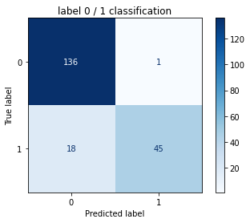

true positive = 45, true negative = 136, false positive = 1, and false negative = 18

reason why we need to focus on these numbers: depending on the domain problem, we need to ensure that the frequency of each predicted label is balanced with the true label. In the extreme case, like robbery, the event that alarm is off is expected to be significantly greater than the event that alarm is on. In real life, robbery does not happen very often. Therefore, if the classifier simply predicts all the time that there is no robbery despite the input feature, then it is safe to say that the model does not perform well. However, this observation can not be concluded from the accuracy, but the above four values can do so instead. Additionally, sometimes we also want to balance between false positive and false negative.

6.3 Single-hidden-layer Neural Networks

Q7

'hidden_layer_sizes = 1'

|  | **training time** | **accuracy** | **F1 score** |
| --- | --- | --- | --- |
| **0** | 0.040994 | 0.805000 | 0.589474 |
| **1** | 0.029000 | 0.315000 | 0.479087 |
| **2** | 0.029998 | 0.315000 | 0.479087 |
| **mean** | 0.033331 | 0.478333 | 0.515883 |
| **std** | 0.005434 | 0.230988 | 0.052037 |

'hidden_layer_sizes = 2'

|  | **training time** | **accuracy** | **F1 score** |
| --- | --- | --- | --- |
| **0** | 0.035000 | 0.315000 | 0.479087 |
| **1** | 0.092000 | 0.810000 | 0.577778 |
| **2** | 0.033000 | 0.315000 | 0.479087 |
| **mean** | 0.053333 | 0.480000 | 0.511984 |
| **std** | 0.027353 | 0.233345 | 0.046523 |

'hidden_layer_sizes = 8'

|  | **training time** | **accuracy** | **F1 score** |
| --- | --- | --- | --- |
| **0** | 0.226997 | 0.880000 | 0.769231 |
| **1** | 0.119003 | 0.805000 | 0.597938 |
| **2** | 0.106000 | 0.840000 | 0.666667 |
| **mean** | 0.150667 | 0.841667 | 0.677945 |
| **std** | 0.054234 | 0.030641 | 0.070383 |

'hidden_layer_sizes = 16'

|  | **training time** | **accuracy** | **F1 score** |
| --- | --- | --- | --- |
| **0** | 0.119999 | 0.870000 | 0.779661 |
| **1** | 0.082000 | 0.885000 | 0.776699 |
| **2** | 0.149003 | 0.900000 | 0.814815 |
| **mean** | 0.117001 | 0.885000 | 0.790392 |
| **std** | 0.027436 | 0.012247 | 0.017312 |

'hidden_layer_sizes = 64'

|  | **training time** | **accuracy** | **F1 score** |
| --- | --- | --- | --- |
| **0** | 0.112000 | 0.895000 | 0.803738 |
| **1** | 0.105002 | 0.890000 | 0.792453 |
| **2** | 0.083001 | 0.870000 | 0.740000 |
| **mean** | 0.100001 | 0.885000 | 0.778730 |
| **std** | 0.012356 | 0.010801 | 0.027771 |

'hidden_layer_sizes = 128'

|  | **training time** | **accuracy** | **F1 score** |
| --- | --- | --- | --- |
| **0** | 0.111001 | 0.895000 | 0.803738 |
| **1** | 0.096006 | 0.910000 | 0.833333 |
| **2** | 0.091002 | 0.890000 | 0.792453 |
| **mean** | 0.099336 | 0.898333 | 0.809841 |
| **std** | 0.008497 | 0.008498 | 0.017238 |

Q8

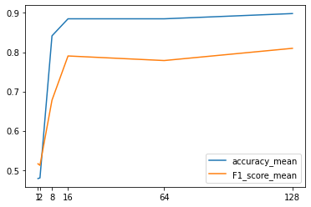

A possible reason for the gap between the accuracy and the F1 score:since accuracy=(TP+TN)/(TP+TN+FN+FP) and F1=TP/(TP+(FP+FN)/2), it is likely that TN is high enough to drag the accuracy well above the F1. This is also the case for Q6.

Q9

|  |  |  |
| --- | --- | --- |
|  | logistic regression | best neural network |
| Training time | 0.004334 | 0.099336 |
| Accuracy | 0.911667 | 0.898333 |
| F1 score | 0.841601 | 0.809841 |

Q10

trend when increase the hidden layer size from 1 to 128:

1. Larger hidden layer model tends to train for much longer than smaller hidden layer model. The reason is obvious which is because larger model has higher number of parameters or weight to be updated compared to smaller model.
2. The accuracy and f1 score increase as the size of hidden layer is increased up to a point when both scores no longer increase or reach the phase with steady but slow increase. According to the plot above, hidden layer size of 16 seems to fit the data well enough, meaning that 16 hidden layers is likely to be close to ideal to capture the all the features from the input and give a correct prediction. Thus, further increasing the hidden layer size is no longer necessary, i.e. 64 and 128 hidden layers are not helpful for the classification. On the other hand, increasing the layer too much may actually decreases the score, which happen when the model becomes very flexible and overfits to the training data.

Part 4: Performance Enhancement

7.1 Hyperparameter Tuning

Q11

Model with rank: 1

Mean validation score: 0.895 (std: 0.012)

Parameters: {'activation': 'tanh', 'hidden_layer_sizes': (64,), 'learning_rate': 'constant', 'solver': 'adam'}

Model with rank: 1

Mean validation score: 0.895 (std: 0.012)

Parameters: {'activation': 'tanh', 'hidden_layer_sizes': (64,), 'learning_rate': 'invscaling', 'solver': 'adam'}

Model with rank: 3

Mean validation score: 0.892 (std: 0.018)

Parameters: {'activation': 'tanh', 'hidden_layer_sizes': (128,), 'learning_rate': 'constant', 'solver': 'adam'}

Model with rank: 3

Mean validation score: 0.892 (std: 0.018)

Parameters: {'activation': 'tanh', 'hidden_layer_sizes': (128,), 'learning_rate': 'invscaling', 'solver': 'adam'}

Model with rank: 5

Mean validation score: 0.891 (std: 0.016)

Parameters: {'activation': 'relu', 'hidden_layer_sizes': (128,), 'learning_rate': 'constant', 'solver': 'adam'}

Model with rank: 5

Mean validation score: 0.891 (std: 0.016)

Parameters: {'activation': 'relu', 'hidden_layer_sizes': (128,), 'learning_rate': 'invscaling', 'solver': 'adam'}

Model with rank: 7

Mean validation score: 0.887 (std: 0.016)

Parameters: {'activation': 'relu', 'hidden_layer_sizes': (64,), 'learning_rate': 'constant', 'solver': 'adam'}

Model with rank: 7

Mean validation score: 0.887 (std: 0.016)

Parameters: {'activation': 'relu', 'hidden_layer_sizes': (64,), 'learning_rate': 'invscaling', 'solver': 'adam'}

Model with rank: 9

Mean validation score: 0.885 (std: 0.011)

Parameters: {'activation': 'tanh', 'hidden_layer_sizes': (64,), 'learning_rate': 'constant', 'solver': 'sgd'}

Model with rank: 10

Mean validation score: 0.883 (std: 0.020)

Parameters: {'activation': 'relu', 'hidden_layer_sizes': (128,), 'learning_rate': 'constant', 'solver': 'sgd'}

Model with rank: 11

Mean validation score: 0.871 (std: 0.007)

Parameters: {'activation': 'tanh', 'hidden_layer_sizes': (128,), 'learning_rate': 'constant', 'solver': 'sgd'}

Model with rank: 12

Mean validation score: 0.837 (std: 0.044)

Parameters: {'activation': 'relu', 'hidden_layer_sizes': (64,), 'learning_rate': 'constant', 'solver': 'sgd'}

Model with rank: 13

Mean validation score: 0.684 (std: 0.002)

Parameters: {'activation': 'logistic', 'hidden_layer_sizes': (128,), 'learning_rate': 'constant', 'solver': 'sgd'}

Model with rank: 14

Mean validation score: 0.680 (std: 0.004)

Parameters: {'activation': 'logistic', 'hidden_layer_sizes': (64,), 'learning_rate': 'constant', 'solver': 'sgd'}

Model with rank: 15

Mean validation score: 0.679 (std: 0.006)

Parameters: {'activation': 'logistic', 'hidden_layer_sizes': (64,), 'learning_rate': 'constant', 'solver': 'adam'}

Model with rank: 15

Mean validation score: 0.679 (std: 0.006)

Parameters: {'activation': 'logistic', 'hidden_layer_sizes': (64,), 'learning_rate': 'invscaling', 'solver': 'adam'}

Q12

Model with rank: 1

Mean validation score: 0.895 (std: 0.012)

Parameters: {'activation': 'tanh', 'hidden_layer_sizes': (64,), 'learning_rate': 'constant', 'solver': 'adam'}

Model with rank: 1

Mean validation score: 0.895 (std: 0.012)

Parameters: {'activation': 'tanh', 'hidden_layer_sizes': (64,), 'learning_rate': 'invscaling', 'solver': 'adam'}

Model with rank: 3

Mean validation score: 0.892 (std: 0.018)

Parameters: {'activation': 'tanh', 'hidden_layer_sizes': (128,), 'learning_rate': 'constant', 'solver': 'adam'}

Model with rank: 3

Mean validation score: 0.892 (std: 0.018)

Parameters: {'activation': 'tanh', 'hidden_layer_sizes': (128,), 'learning_rate': 'invscaling', 'solver': 'adam'}

Q13

Accuracy = 0.8727810650887574, F1 score = 0.74

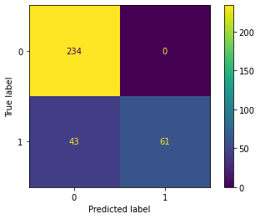

7.2 Comparison of Classification Methods

Q14

In logistic regression, it is generally not applicable to non-linear problems, and it can only predict categorical outcome, as in the above datasets.

Neural network often needs more training time compared to logistic regression when the hidden layer is comparably large.

Q15

|  | **accuracy** | **F1 score** |
| --- | --- | --- |
| **constant** | 0.872781 | 0.739394 |
| **optimal** | 0.896450 | 0.808743 |
| **invscaling** | 0.872781 | 0.739394 |

Q16

|  | **accuracy** | **F1 score** |
| --- | --- | --- |
| **logistic** | 0.70 | 0.189189 |
| **tanh** | 0.91 | 0.836364 |
| **relu** | 0.90 | 0.814815 |

Q17

Logistic: not zero centered, vanishing gradient

Tanh: vanishing gradient when saturated

Relu: not zero centered, never activate at less than zero values or vanishing gradient which lead to not updating weight or parameters